**Proximity Switch: Quick Guide**

# Introduction

The proximity switch is an access switch that senses the motion of a hand, finger, or foot waved over a light sensor. This switch is suitable for users with some finger or hand movement, but limited strength, or for triggering assistive technology at a distance.

The unit works by detecting a shadow over its main sensor in an evenly lit environment. The sensitivity adjustments allow users and caretakers to change the sensing range up to 15cm.

# Features

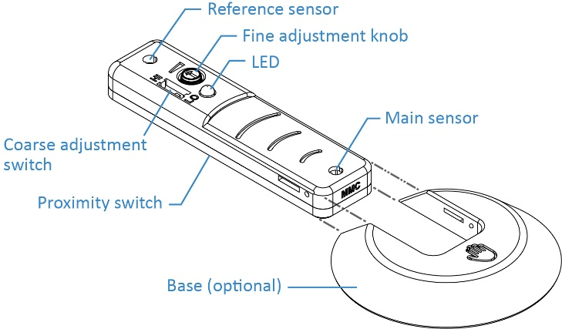

# Usage

1. Connect the 3.5mm audio cable from the proximity switch to the assistive device, and turn the fine adjustment knob fully clockwise. If the LED stays lit, dial the knob back (counter clockwise) until the LED goes out.
2. Wave your hand or finger over the main sensor. The LED will turn green when activated. 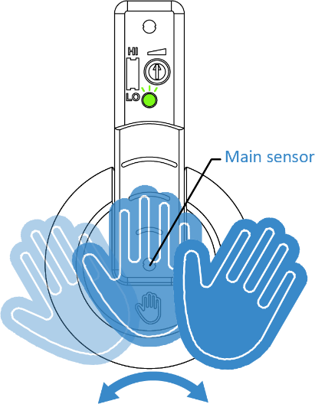
3. Adjust the sensitivity of the sensor using the adjustment knobs. 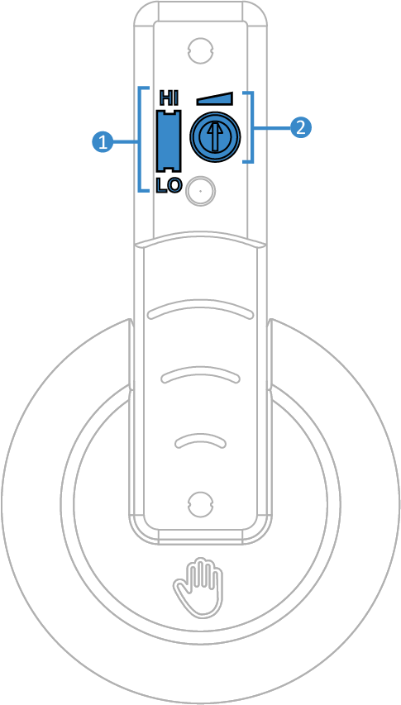  
   **1.** **Coarse adjustment switch**:Slide the switch using a pen to **HI** to detect up to 15cm of motion range and **LO** for up to 7.5cm

**2. Fine adjustment knob:**  
Turn the fine adjustment knob with pen or fingernail towards the **right** to increase the sensitivity and towards the **left** to decrease it.

1. (Optional) For users low finger strength, slide and clip the 3D printed base to the proximity switch to use it as a ramp to reach the main sensor.

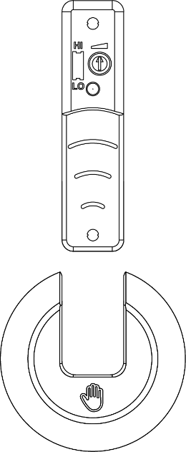

# Mounting Options

Adhere a strip of Velcro to the underside of the proximity switch for mounting.

# Changing the Battery

1. Flip the proximity switch over and use a Phillips screwdriver (+) to take out the two screws.  
    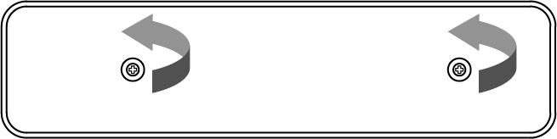
2. Take off the top case to reveal the battery.  
   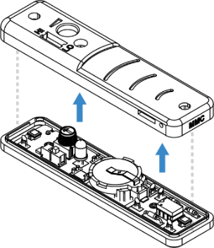
3. Replace with a new CR2032 coin cell battery.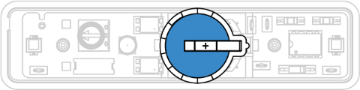
4. Flip the proximity switch over and use a Phillips screwdriver (+) to take out the two screws.  
    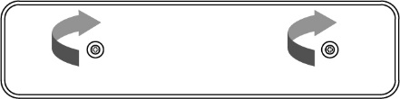

# Lighting

For normal use, we recommend using the proximity switch under normal office lighting levels (150-500 lux), with the light source directly overhead for maximum sensing range. The proximity switch is capable working under a wide range of lighting levels, from approximately 4 lux (at a reduced range) to 107527 lux (full sunlight). Regardless of light level, maximum range is achieved when the main light source is even, and directly facing the sensors on the proximity switch.

If the proximity switch is in the normal orientation (facing up) the light should be overhead. For side operation, the light source should face from the side, though for short range finger activation, the lighting requirements are less critical. Keep in mind, the proximity switch can be triggered by anything passing over the main sensor. Avoid placing the proximity switch anywhere where pets, birds, or equipment can walk, fly or swing over the main sensor.

# Cleaning

The 3D printed case of proximity switch can be wiped clean with a paper towel or soft cloth, using a mild household detergent solution. Non-toxic biodegradable all-purpose cleaners are preferred. If dust or particles fall into the light sensor wells, they can be gently swabbed out using a dry Q-Tip. Do not use abrasive cleaners, as they will scratch the surface of the unit. Do not submerge the unit in any liquid, as it will damage the internal electronic components. If disinfection is required, Isopropyl alcohol may be applied with a wipe.

# Specification

|  |  |
| --- | --- |
| Specification | Details |
| Size | 110x27x14mm (switch only)  143x82x14mm (switch & base) |
| Battery | CR2032 cell, 3 volts (replaceable) |
| Battery Life | 6 months |
| Cord | 3mm switch plug cord length: 122cm (4 feet). |